API Fundamentals (Common Web API Testing interview questions)
1. What is an API?
An API (Application Programming Interface) is a software intermediary that enables two applications to communicate with each other. It comprises a number of subroutine definitions, logs, and tools for creating application software.
In an API testing interview, you could be asked to give some API examples, here are the well-known ones: Google Maps API, Amazon Advertising API, Twitter API, YouTube API, etc.
2. What are the main differences between API and Web Service?
- All Web services are APIs but not all APIs are Web services.
- Web services might not contain all the specifications and cannot perform all the tasks that APIs would perform.
- A Web service uses only three styles of use: SOAP, REST, and XML-RPC for communication whereas API may be exposed in multiple ways.
- A Web service always needs a network to operate while APIs don’t need a network for operation.
3. What are the Limits of API Usage?
Many APIs have a certain limit set up by the provider. Thus, try to estimate your usage and understand how that will impact the overall cost of the offering. Whether this will be a problem depends in large part on how data is leveraged. Getting caught by a quota and effectively cut off because of budget limitations will render the service (and any system or process depending on it) virtually useless.
4. How does an API work?
An API (Application Programming Interface) functions as a communication layer between two software applications. It defines a set of rules and protocols that allow applications to interact with each other. In the case of a Web API, the process usually works as follows:
- Client Request: The client (e.g., a web browser, mobile app, or another server) sends an HTTP request to the API's endpoint. This request specifies the operation (e.g., retrieving data, creating a resource) and includes any necessary parameters, headers, or a payload.
- Server Processing: The API's server receives the request, processes the data, performs the required operations (e.g., querying a database or triggering a service), and formulates a response.
- Response: The server sends an HTTP response back to the client, which typically includes a status code (e.g., 200 OK), headers, and a payload (e.g., data in JSON or XML format).
- Client Handling: The client processes the response and updates its interface or behavior based on the data received.
5. What are the main types of API?
There are 4 main types of API:
- Public APIs (Open APIs): Available to any developer, public APIs are open to external users with minimal restrictions, typically requiring an API key for access. Examples include the Twitter and Google Maps APIs.
- Private APIs: Used internally within organizations, private APIs connect internal systems or microservices and are not exposed to external users. They help automate workflows and integrate backend systems.
- Partner APIs: Shared with specific external partners, these APIs enable controlled access to systems or data for business collaborations, managed through authentication and SLAs.
- Composite APIs: These APIs combine multiple requests into one, allowing clients to interact with several services or perform multiple operations in a single call, improving efficiency and performance.
HTTP Methods and Communication Protocols
6. What are some common protocols used in API testing?
Common protocols include HTTP, REST, SOAP, JMS, and UDDI. These define how data is structured and transmitted between systems during API testing.
7. Compare the differences between HTTP, REST, SOAP, JMS, and UDDI
Protocol | Data Format | Complexity | Communication Style | Transport Protocol | Use Cases
HTTP | Typically plain text or HTML | Simple, lightweight | Synchronous (request-response) | HTTP | Web communication, page requests
REST | JSON (commonly), XML | Flexible, lightweight | Synchronous (request-response) | HTTP | Web/mobile APIs, microservices, simple web-based apps
SOAP | XML | Rigid but reliable, follows strict standards | Synchronous (request-response) | HTTP, SMTP, JMS, others | Enterprise apps needing security, transactions, complex services
JMS | No fixed format (varies by implementation) | Moderate complexity | Asynchronous (message queuing) | Specific to message queues (JMS protocol) | Internal systems, asynchronous communication in enterprise environments
UDDI | XML | Moderate, requires registry setup | Synchronous (service discovery) | HTTP, SOAP | Web service discovery, service registries (primarily for SOAP services)

8. What are the core components of an HTTP request?
An HTTP request includes:
- Method (GET, POST, etc.)
- URI (resource location)
- Headers (metadata)
- Body (data, if applicable)
- HTTP version.
9. What does an HTTP method do?
The HTTP method specifies the action to be performed on the resource. Common methods include:
- GET: Retrieve data from the server.
- POST: Send data to the server to create or update a resource.
- PUT: Replace a resource.
- DELETE: Remove a resource.
- PATCH: Partially update a resource.
Let’s put that into a specific scenario. Say you’re testing an online bookstore API.
- The GET can retrieve a list of books from the store’s database
- The POST can add data of new books to the store’s database
- The PUT can replace a certain book with a new one
- The DELETE can remove a book from the database
- The PATCH update only a few details of a book (such as its price), leaving everything else unchanged
10. What do the URI and the Headers do in an API?
The URI specifies the location of the resource on the server. It includes the path to the resource and query parameters (e.g., example.com/resource?id=123), helping the server identify what data or action is requested.
Headers carry additional information about the request or response, such as:
- Content-Type: Specifies the format of the body (e.g., JSON, XML).
- Authorization: Contains credentials to authenticate the request.
- User-Agent: Identifies the client making the request.
API Design and Architecture (Common Web API Testing interview questions)
11. What are some architectural styles for creating a Web API?
This is one of the fundamental Web API interview questions. Bellows are four common Web API architectural styles:
- HTTP for client-server communication
- XML/JSON as formatting language
- Simple URI as the address for the services
- Stateless communication
12. Who can use a Web API?
Web API can be consumed by any clients which support HTTP verbs such as GET, PUT, DELETE, and POST. Since Web API services do not require configuration, they can be easily used by any client. In fact, even portable devices such as mobile devices can easily use Web API, which is undoubtedly the biggest advantage of this technology.
13. What are the principles of an API test design?
- Setup: Initialize test data and configure the necessary environment, such as starting services or creating objects.
- Execution: Send API requests with defined parameters, methods, and data, and observe how the system behaves.
- Verification: Validate the response against expected results, including status codes, response data, and schema.
- Reporting: Document test outcomes, marking them as passed, failed, or blocked based on validation results.
- Cleanup: Return the environment to its pre-test state, such as deleting test data or stopping services.
14. What is the importance of statelessness in API architecture?
Statelessness in API architecture means each request from the client contains all the necessary information for the server to process it, without relying on stored context from previous requests. This is crucial because:
- Scalability: Stateless APIs are easier to scale horizontally, as no session information needs to be stored between requests.
- Reliability: Each request is independent, which reduces the chance of errors due to inconsistent server-side states.
- Simplicity: It simplifies both server and client logic, as no complex session management is required.
- Performance: Stateless APIs can be cached more efficiently, improving performance and reducing server load.
Testing APIs (Common Web API Testing interview questions)
15. What is API Testing?
API testing is a kind of software testing that determines if the developed APIs meet expectations regarding the functionality, reliability, performance, and security of the application.
📚 Learn More: What is API Testing?
16. What are the advantages of API Testing?
In an API interview, they are likely to ask about the advantages of API testing. So be prepared with the significant ones such as:
- Test for Core Functionality: API testing provides access to the application without a user interface. The core and code-level of functionalities of the application will be tested and evaluated early before the GUI tests. This will help detect minor issues which can become bigger during the GUI testing.
- Time Effective: API testing usually is less time-consuming than functional GUI testing. The web elements in GUI testing must be polled, which makes the testing process slower. Particularly, API test automation requires less code so it can provide better and faster test coverage compared to GUI test automation. These will result in cost saving for the testing project.
- Language-Independent: In API testing, data is exchanged using XML or JSON. These transfer modes are completely language-independent, allowing users to select any coding language when adopting automation testing services for the project.
- Easy Integration with GUI: API tests enable highly integrable tests, which is particularly useful if you want to perform functional GUI tests after API testing. For instance, simple integration would allow new user accounts to be created within the application before a GUI test started.
18. What is the test environment of API?
Setting up the API’s test environment is not an easy task, so you should have a ready answer if your API testing interview is coming. The test environment of API is a bit complete and requires the configuration of the database and server, depending on the software requirements. No GUI (Graphical User Interface) is available in this test form.
When the installation process is complete, API is verified for proper operation. Throughout the process, the API called from the original environment is set up with different parameters to study the test results.
19. What are the common API testing types?
While there are certainly specialty tests, and no list can be asked to be comprehensive in this realm, most tests fit broadly into the following nine categories that you should remember before attending an API testing interview.
- Validation Testing
- Functional Testing
- UI Testing
- Load testing
- Runtime/ Error Detection
- Security testing
- Penetration testing
- Fuzz testing
- Interoperability and WS Compliance testing
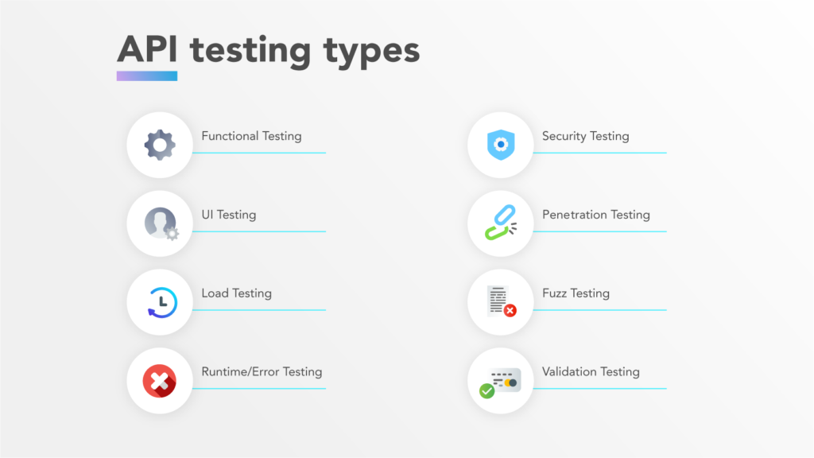
20. What is contract testing?
Contract testing is a technique used to verify that an API adheres to the agreed-upon "contract" between the service provider and the consumer. It ensures:
- Compatibility: The API provides the expected inputs and outputs (data format, structure, and behavior).
- Integrity: Changes in the API don’t break existing client integrations.
Contract testing is particularly useful in microservices, where services interact with each other via APIs.
21. What is fuzz testing?
Fuzz testing (or fuzzing) involves sending random, invalid, or unexpected inputs to an API to test its robustness and error-handling capabilities. Fuzz testing helps identify:
- Vulnerabilities: Unhandled errors or crashes.
- Security Issues: Exposing potential flaws like buffer overflows, injection attacks, or data leaks. In API testing, fuzz testing is used to simulate unpredictable user behavior or malicious inputs to see how the API responds under stress.
23. What is microservices architecture?
Microservices architecture is a design approach in which an application is built as a collection of small, independent services that each perform a specific business function. These services usually communicate with each other via APIs (like REST or gRPC), to collectively form a complete system.
Key characteristics of a microservices architecture include:
- Independence: Each service is independently deployable, testable, and scalable. Teams can work on different services in parallel.
- Single Responsibility: Each microservice is designed to handle one specific function, such as user management, payment processing, or inventory.
- Decentralized Data Management: Each service typically manages its own database, avoiding a centralized monolithic database.
- Technology Flexibility: Microservices can be developed in different languages or frameworks, depending on what best suits each service’s needs.
- Fault Isolation: Failure in one microservice doesn’t necessarily impact the entire system, improving system reliability.
24. What is the procedure to perform API testing?
- Choose the suite to add the API test case
- Choose the test development mode
- Demand the development of test cases for the required API methods
- Configure the control parameters of the application and then test conditions
- Configure method validation
- Execute the API test
- Check test reports and filter API test cases
- Arrange all API test cases
25. What must be checked when performing API testing?
During the API testing process, a request is raised to the API with the known data. This way you can analyze the validation response. While testing an API, you should consider:
- Accuracy of data
- Schema validation
- HTTP status codes
- Data type, validations, order, and completeness
- Authorization checks
- Implementation of response timeout
- Error codes in case API returns, and
- Non-functional testing like performance and security testing
26. What is the best approach method to perform API testing?
The following factors should be considered when performing API testing:
- Defining the correct input parameters
- Verifying the calls of the mixture of two or more added value parameters
- Defining the basic functionality and scope of the API program
- Writing appropriate API test cases and making use of testing techniques such as equivalence class, boundary value, etc. to check the operability
- Testing case execution
- Comparing the test result with the expected result
- Verifying the API behavior under conditions such as connection to files and so on
27. How do you handle dynamic data in API testing?
- Data Parameterization: Using data-driven tests where input values are generated dynamically from a data source (e.g., database, files).
- Assertions with Patterns: Instead of hardcoding expected values, validate dynamic responses with patterns, regex, or partial matches.
- State Management: Keeping track of the state of the system and using that information (such as generated user IDs) in subsequent tests.
- Mocking: For external services that provide dynamic data, mocks or stubs can simulate expected responses.
- Environment-specific Data: Adjust test data based on the environment (e.g., development vs. production).
28. What tools could be used for API testing?
There are a lot of different API testing tools available that enterprises around the world are using to ensure that their APIs are up and running smoothly. A few common tools are Katalon Studio, Postman, SoapUi Pro, Apigee, etc.
29. What are the differences between API Testing and Unit Testing?
API Testing | Unit Testing
Conducted by QA Team | Conducted by the development team
Mostly black-box testing | White box testing
Aimed to assess the full functionality of the system for it will be employed by the end-user (external developers who will use your API) | Used to verify whether each unit in isolation performs as expected or not
Often run after the build is ready and authors do not have access to the source code | Each of the code modules must be ensured to pass the unit test before being built by developers
📚 Read More: What is Unit Testing? A Comprehensive Guide
30. What are the differences between API Testing and UI Testing?
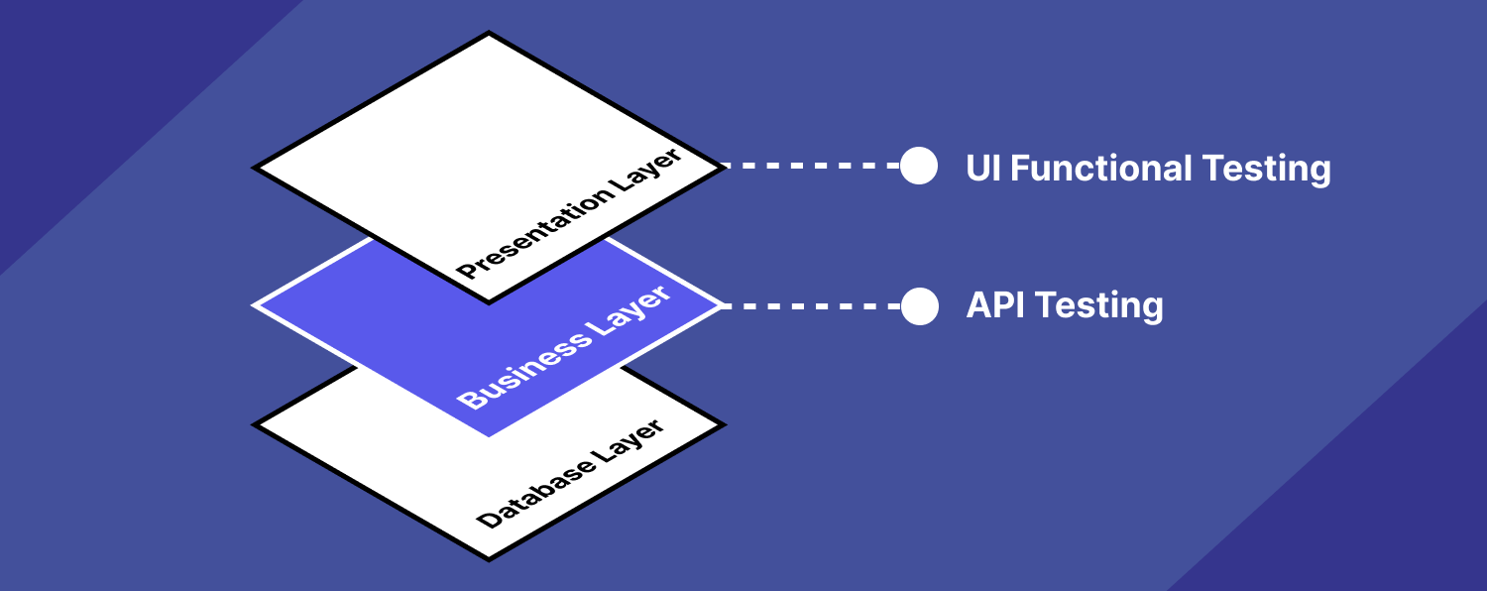
- API enables the communication between two separate software systems. A software system implementing an API contains functions or subroutines that can be executed by another software system.
- UI testing refers to testing graphical interfaces such as how users interact with the applications, and testing application elements like fonts, images, layouts, etc. UI testing basically focuses on the look and feel of an application.
31. What are the major challenges faced in API testing?
If you can overcome the challenges in API testing, you can be confident in the API testing interview too. They are:
- Parameter Selection
- Parameter Combination
- Call sequencing
- Output verification and validation
- Another important challenge is providing input values, which is very difficult as GUI is not available in this case.
32. What are the testing methods that come under API testing?
One of the most common Web API testing interview questions is about the testing methods. They are:
- Unit Testing and Functional testing
- Load testing to test the performance under load
- Discovery testing to list, create and delete the number of calls documented in the API
- Usability and Reliability testing to get consistent results
- Security and Penetration testing to validate all types of authentication
- Automation testing to create and run scripts that require regular API calls
- End to end Integration and Web UI testing
- API documentation testing to determine its efficiency and effectiveness
33. Why is API testing considered as the most suitable form for Automation testing?
API testing is now preferred over GUI testing and is considered as most suitable because:
- It verifies all the functional paths of the system under test very effectively.
- It provides the most stable interface.
- It is easier to maintain and provides fast feedback.
34. What are common API errors that are often found?
Not only API fundamental questions, the interviewer also determines your knowledge and experience by asking about the API errors in a Web API testing interview. So the most common ones are:
- Missing module errors
- Documentation errors
- Parameter validation errors
- And some standard error expectations as if the result is not so predicted then the occurrence of errors can be seen and the same warnings are specified in the form of a message. There can be one or more warnings within an individual module.
35. What kinds of bugs that API testing would often find?
- Missing or duplicate functionality
- Fails to handle error conditions gracefully
- Stress
- Reliability
- Security
- Unused flags
- Not implemented errors
- Inconsistent error handling
- Performance
- Multi-threading issues
- Improper errors
API Documentation (Common Web API Testing interview questions)
36. What is API documentation?
The API documentation is a complete, accurate technical writing giving instructions on how to effectively use and integrate with an API. It is a compact reference manual that has all the information needed to work with the API and helps you answer all the API testing questions with details on functions, classes, return types, arguments, and also examples and tutorials.
37. What are API documentation templates that are commonly used?
There are several available API documentation templates that help to make the entire process simple and straightforward, which could be answered in your API testing interview, such as:
- Swagger
- Miredot
- Slate
- FlatDoc
- API blueprint
- RestDoc
- Web service API specification
38. What are the key components of good API documentation?
- Endpoint Descriptions: Clear explanations of all API endpoints (e.g., /users, /products), including their purpose.
- HTTP Methods: Indicate the allowed methods (GET, POST, PUT, DELETE) for each endpoint.
- Request Parameters: Define query parameters, path parameters, headers, and body requirements (e.g., data types, format).
- Authentication: Provide instructions on how to authenticate (e.g., API keys, OAuth tokens) and any necessary security headers.
- Request/Response Examples: Include detailed examples of both requests and responses (in formats like JSON or XML) to show expected input/output.
- Status Codes: List the possible HTTP status codes (e.g., 200, 404, 500) for each endpoint and explain what they represent.
- Error Handling: Document error messages and how clients should handle common errors.
- Rate Limits and Throttling: Describe any rate limits or usage quotas applied to the API.
- Versioning: Provide clear guidance on API versioning and deprecated endpoints, if applicable.
39. What are some common pitfalls to avoid in API documentation?
- Outdated Information: Failing to update the documentation when the API changes, leading to inaccurate or incomplete instructions.
- Lack of Examples: Not including concrete examples of requests and responses, making it harder for developers to implement the API.
- Missing Error Details: Not providing explanations for common error responses or missing error-handling guidelines.
- Vague Descriptions: Using unclear or overly technical language that makes it difficult for developers to understand endpoint functions.
- Inconsistent Formatting: Inconsistent use of terms, layout, or structure across different parts of the documentation.
- No Authentication Guidance: Leaving out critical details on how to authenticate or secure API calls.
- Ignoring Edge Cases: Failing to document how the API behaves in uncommon or complex scenarios (e.g., rate limiting, large datasets).
- Poor Navigation: Making it difficult to find information due to disorganized or non-intuitive documentation structure.
40. When writing API documents, what must be considered?
- Source of the content
- Document plan or sketch
- Delivery layout
- Information needed for every function in the document
- Automatic document creation programs
41. How often are the APIs changed and, more importantly, deprecated?
APIs, especially modern RESTful APIs, is a nice creation that can certainly simplify and accelerate integration efforts, which makes it more likely you will benefit from them. But APIs can and do change for various reasons, sometimes abruptly, and hence REST APIs do not differ from traditional integration methods in this respect. If an API call is obsolete and disappears, your procedure will interrupt and it is important to understand how often the APIs you depend on change or are deprecated.
REST API Testing interview questions
42. What is REST?
REST (Representational State Transfer) is an architectural style for developing web services that exploit the ubiquity of HTTP protocol and uses the HTTP method to define actions. It revolves around resources where every component is a resource that can be accessed through a shared interface using standard HTTP methods.
In REST architecture, a REST Server provides access to resources and REST client accesses and makes these resources available. Here, each resource is identified by URIs or global IDs, and REST uses multiple ways to represent a resource, such as text, JSON, and XML. XML and JSON are nowadays the most popular representations of resources.
43. What is a RESTFul Web Service?
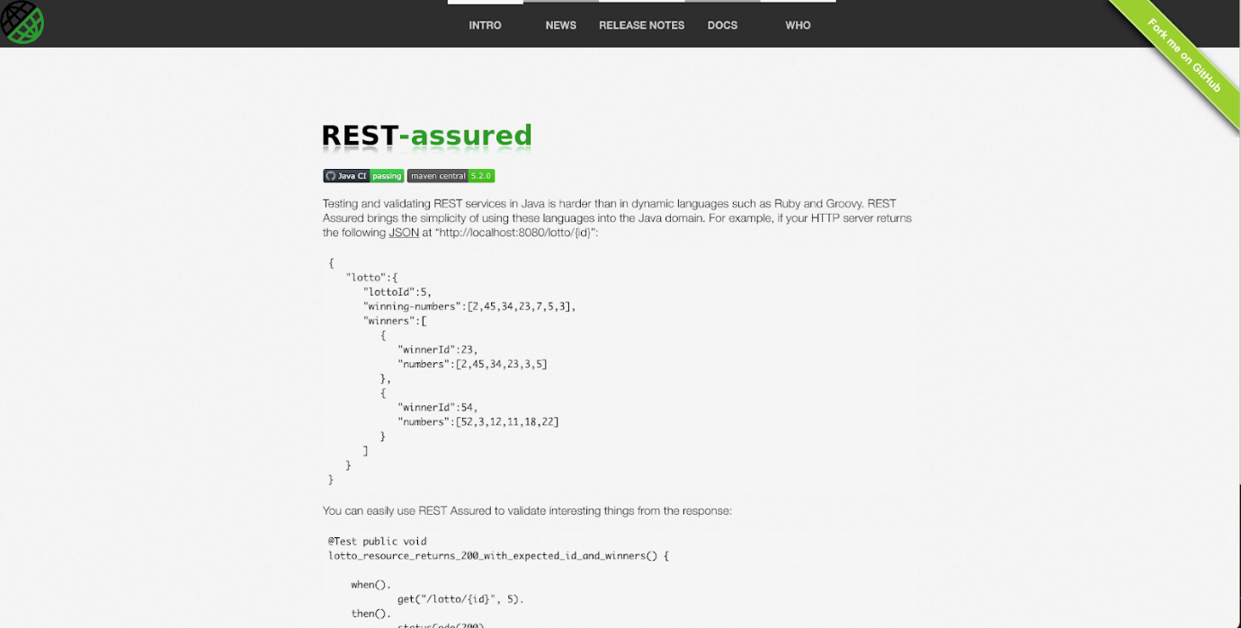
Mostly, there are two kinds of Web Services that should be remembered in your next API testing interview:
- SOAP (Simple Object Access Protocol) – an XML-based method to expose web services.
- Web services developed in the REST style are referred to as RESTful web services. These web services use HTTP methods to implement the concept of REST architecture. A RESTful web service usually defines a URI, Uniform Resource Identifier a service, and provides resource representation like JSON and a set of HTTP methods.
44. What is a “Resource” in REST?
REST architecture treats any content as a resource, which can be either text files, HTML pages, images, videos, or dynamic business information.
REST Server gives access to resources and modifies them, where each resource is identified by URIs/ global IDs.
45. What is the most popular way to represent a resource in REST?
REST uses different representations to define a resource like text, JSON, and XML.
XML and JSON are the most popular representations of resources.
46. Which protocol is used by RESTful Web services?
RESTful web services use the HTTP protocol as a medium of communication between the client and the server.
47. What are some key characteristics of REST?
Key characteristics of REST are likely asked in a Web API Testing interview. So please get the answer ready in your mind with these 2 ones:
- REST is stateless, therefore the SERVER has no status (or session data)
With a well-applied REST API, the server could be restarted between two calls, since all data is transferred to the server
- Web service uses POST method primarily to perform operations, while REST uses GET for accessing resources.
48. What is messaging in RESTful Web services?
RESTful web services use the HTTP protocol as a communication tool between the client and the server. The technique that when the client sends a message in the form of an HTTP Request, the server sends back the HTTP reply is called Messaging. These messages comprise message data and metadata, that is, information on the message itself.
49. What are the core components of an HTTP request?
An HTTP request contains five key elements:
- An action showing HTTP methods like GET, PUT, POST, and DELETE.
- Uniform Resource Identifier (URI), which is the identifier for the resource on the server.
- HTTP Version, which indicates HTTP version, for example-HTTP v1.1.
- Request Header, which carries metadata (as key-value pairs) for the HTTP Request message. Metadata could be a client (or browser) type, format supported by the client, format of a message body format, cache settings, and so on.
- Request Body, which indicates the message content or resource representation.
50. What are the most commonly used HTTP methods supported by REST?
- GET is only used to request data from a specified resource. Get requests can be cached and bookmarked. It remains in the browser history and has length restrictions. GET requests should never be used when dealing with sensitive data.
- POST is used to send data to a server to create/update a resource. POST requests are never cached and bookmarked and do not remain in the browser history.
- PUT replaces all current representations of the target resource with the request payload.
- DELETE removes the specified resource.
- OPTIONS is used to describe the communication options for the target resource.
- HEAD asks for a response identical to that of a GET request, but without the response body.
51. Can GET request be used instead of PUT to create a resource?
The PUT or POST method should be used to create a resource. GET is only used to request data from a specified resource.
52. Is there any difference between PUT and POST operations?
PUT and POST operations are quite similar, except for the terms of the result generated by them.
PUT operation is idempotent, so you can cache the response while the responses to POST operation are not cacheable, and if you retry the request N times, you will end up having N resources with N different URIs created on the server.
In a Web API Testing interview, you should give a specific example for PUT and POST operations to make it crystal clear to the interviewer. Below is an example:
Scenario: Let’s say we are designing a network application. Let’s list down a few URIs and their purpose to get to know when to use POST and when to use PUT operations.
API Lifecycle Management Interview Questions
53. What are the key stages of the API lifecycle, and why are they important?
- Planning & Design: Define the API’s purpose, endpoints, data formats, and security requirements. This ensures the API meets business goals and user needs.
- Development: Implement the API following best practices for security, scalability, and maintainability.
- Testing: Ensure functionality, performance, and security through unit, integration, and load testing. This reduces the risk of issues in production.
- Deployment: Release the API to a production environment. Proper deployment strategies (e.g., staging environments) minimize disruptions.
- Versioning & Maintenance: Regularly update and fix the API while maintaining older versions. This ensures ongoing support and feature enhancements.
- Monitoring & Analytics: Track API usage, performance, and errors in real time. Monitoring helps in identifying issues and understanding usage patterns.
- Deprecation: Phasing out outdated APIs in a controlled manner. Proper deprecation ensures users have time to transition to newer versions.
These stages ensure the API is developed, maintained, and managed effectively, providing a smooth experience for users.
54. How do you handle versioning in API management, and why is it essential?
Versioning is managed by labeling different API iterations (e.g., v1, v2) to indicate changes or updates. Common strategies include:
- URI Versioning: Adding the version number to the endpoint (e.g., /api/v1/users).
- Header Versioning: Including the version in the request headers (e.g., X-API-Version: 2).
- Query Parameter Versioning: Using query parameters (e.g., /users?version=1).
Versioning is essential because:
- It allows backward compatibility, ensuring existing clients continue functioning when new features or breaking changes are introduced.
- It provides flexibility for users to adopt new features at their own pace.
55. What strategies can be used to deprecate an API without disrupting users?
- Advanced Notice: Inform users well in advance of the deprecation, providing a clear timeline for when the API will no longer be available.
- Dual Support: Run both old and new API versions in parallel for a transition period, allowing users time to migrate.
- Clear Documentation: Provide detailed documentation for the new version and migration paths.
- Grace Period: Offer a grace period for users unable to migrate immediately, providing support until they can switch.
- Deprecation Warnings: Include deprecation warnings in the API responses to alert users when they are using deprecated endpoints.
These strategies ensure a smooth transition and minimize disruption to API consumers.
56. How do you manage API dependencies during updates or changes?
- Dependency Mapping: Identify all internal and external dependencies (databases, third-party APIs, microservices) and document their interactions.
- Testing: Perform regression testing to ensure that dependencies are not broken by updates.
- Mocking & Stubbing: Use mocks or stubs to simulate dependent services during development and testing.
- Backward Compatibility: Ensure that updates do not break existing dependencies by maintaining compatibility or using versioning.
- Communication: Notify all stakeholders and dependent teams or clients about changes to avoid issues in downstream services.
Managing dependencies reduces the risk of breaking functionality and ensures smoother updates.
57. How do you ensure backward compatibility when releasing a new version of an API?
- Versioning: Release the new version separately (e.g., /v2/) so the old version remains functional.
- Additive Changes: Introduce non-breaking changes (e.g., adding new fields or features) rather than modifying existing functionality.
- Deprecation Warnings: Start issuing warnings when deprecated features are used, but keep the old functionality operational for a grace period.
- Contract Testing: Use contract testing to ensure that existing clients can still communicate effectively with the API.
- Feature Flags: Gradually introduce changes using feature flags, which allow new features to be enabled or disabled without affecting the old version.
General Non-technical Interview Questions For API Testers
These are the more general and non-technical questions that require you to demonstrate your experience:
- Can you describe a challenging testing project you worked on and how you overcame the obstacles?
- How do you prioritize your tasks when multiple testing deadlines are approaching?
- How do you ensure effective communication with developers and project managers during the testing process?
- What steps do you take to ensure that you fully understand the requirements before starting testing?
- How do you handle disagreements with developers over whether a bug is valid or should be fixed?
- How do you stay organized when managing multiple test cases and defects at once?
- What strategies do you use to maintain focus and attention to detail during repetitive testing tasks?
- Can you give an example of a time when you missed a bug during testing? How did you handle the situation?
- How do you stay up to date with industry trends and best practices in testing?
- What motivates you as a tester, and how do you maintain a high level of quality in your work?
We recommend the STAR framework to answer these questions. It is a structured method used to answer behavioral interview questions by clearly explaining past experiences. It stands for Situation, Task, Action, and Result, and it helps ensure your answers are focused, organized, and demonstrate the skills or behaviors the interviewer is looking for.
Here’s the example:
Situation: Describe the context or background of a specific event or challenge you faced. This sets the scene and provides the interviewer with relevant details.
- Example: “In my previous role as a QA tester, we were preparing to launch a major product update under tight deadlines.”
Task: Explain your specific role or responsibility in the situation. Focus on what needed to be accomplished.
- Example: “My task was to lead the testing effort for the update and ensure there were no major defects.”
Action: Describe the specific actions you took to address the task. Focus on the steps you personally took to handle the situation.
- Example: “I coordinated with the development team to clarify the test requirements, created detailed test cases, and organized daily stand-ups to track progress.”
Result: Share the outcome or result of your actions. Try to quantify the impact if possible (e.g., time saved, increased efficiency) and ensure the result is positive.
- Example: “As a result, we identified and resolved several critical bugs early, and the update was launched on time with minimal issues. The product received positive feedback from users.”

